HTML Assignment-Tables & Lists
Part-A
1.What is a list in HTML?
A. A list in HTML is used to display a group of related items in an organized way.
2. What is the difference between Ordered List and Unordered List?
A. Ordered List: Shows items with numbers (1, 2, 3).
Unordered List: Shows items with bullets (•).
3.Write the purpose of <ol>, <ul>, and <li> tags.
<ol> – Used to create an ordered list, where items are displayed in a specific order using numbers letters.
<ul> – Used to create an unordered list, where items are displayed using bulletpoints.
<li> – Used to define each individual item inside an ordered or unordered list.
4. Create an ordered list of 5 subjects.
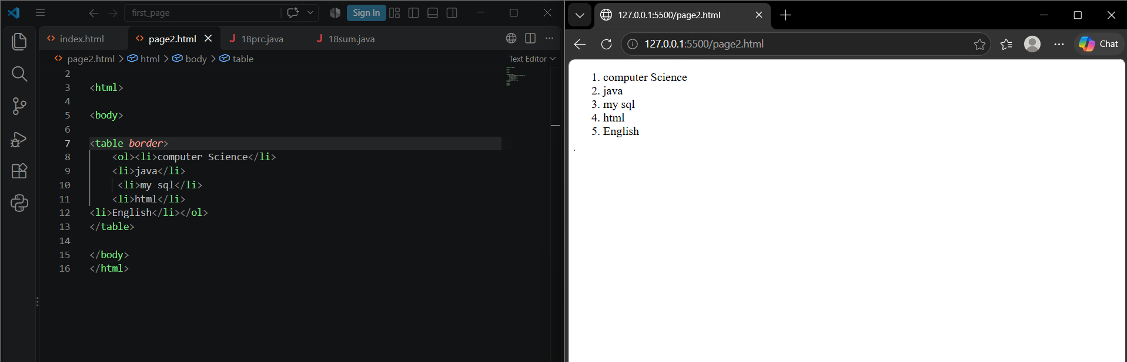
5. Create an unordered list of 5 programming languages.
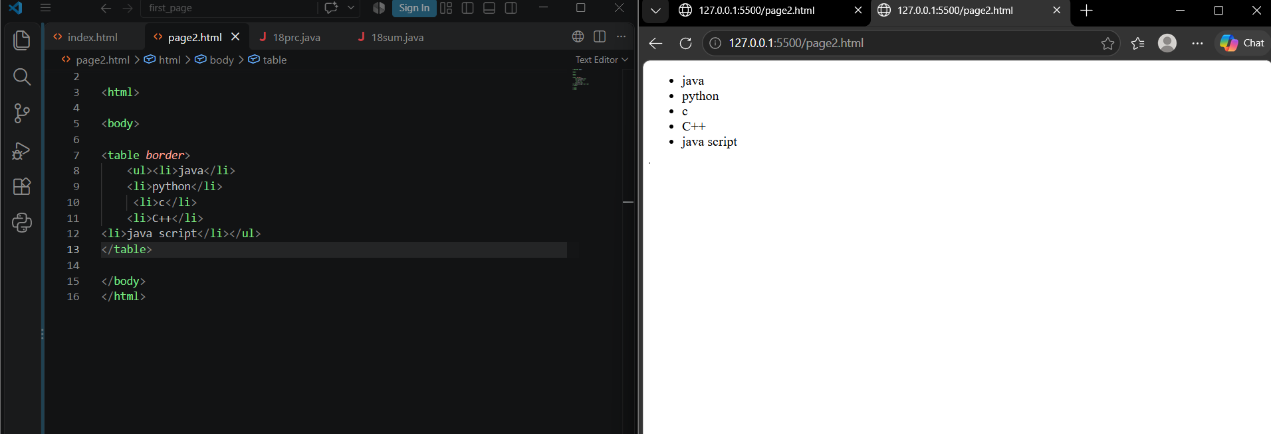
6. Create an ordered list using different numbering types.
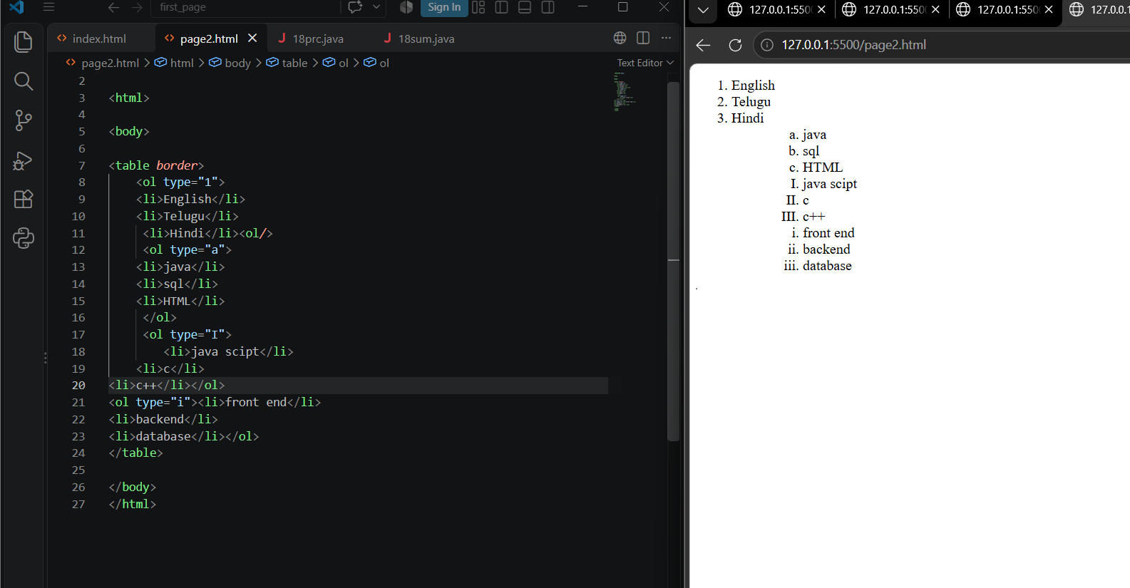
7. Create an unordered list using different bullet styles.
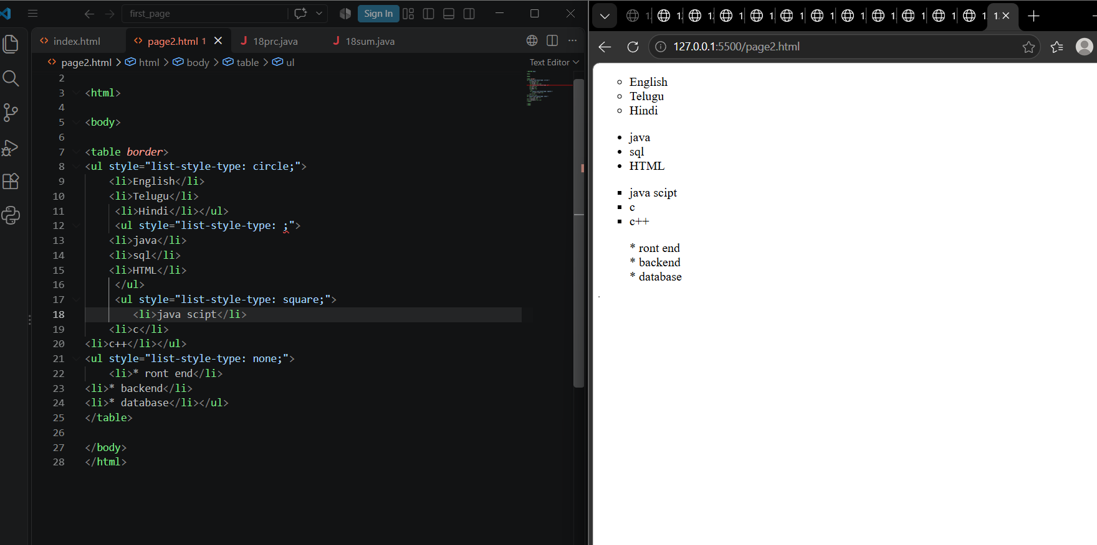
8. Create a nested list containing:
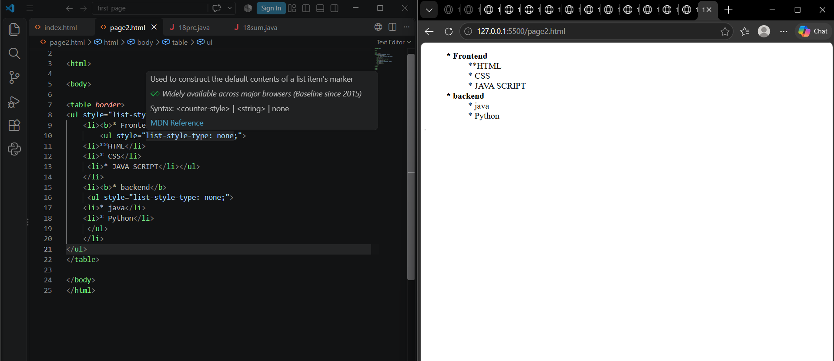

Part-B
9.What is a table in HTML?
A.A table in HTML is used to display data in rows and columns.
10. Write the purpose of <table>, <tr>, <th>, and <td> tags?
- <table> – Creates a table.
- <tr> – Creates a table row.
- <th> – Creates a table heading.
- <td> – Creates a table data cell.
11. Create a table with 3 rows and 3 columns.
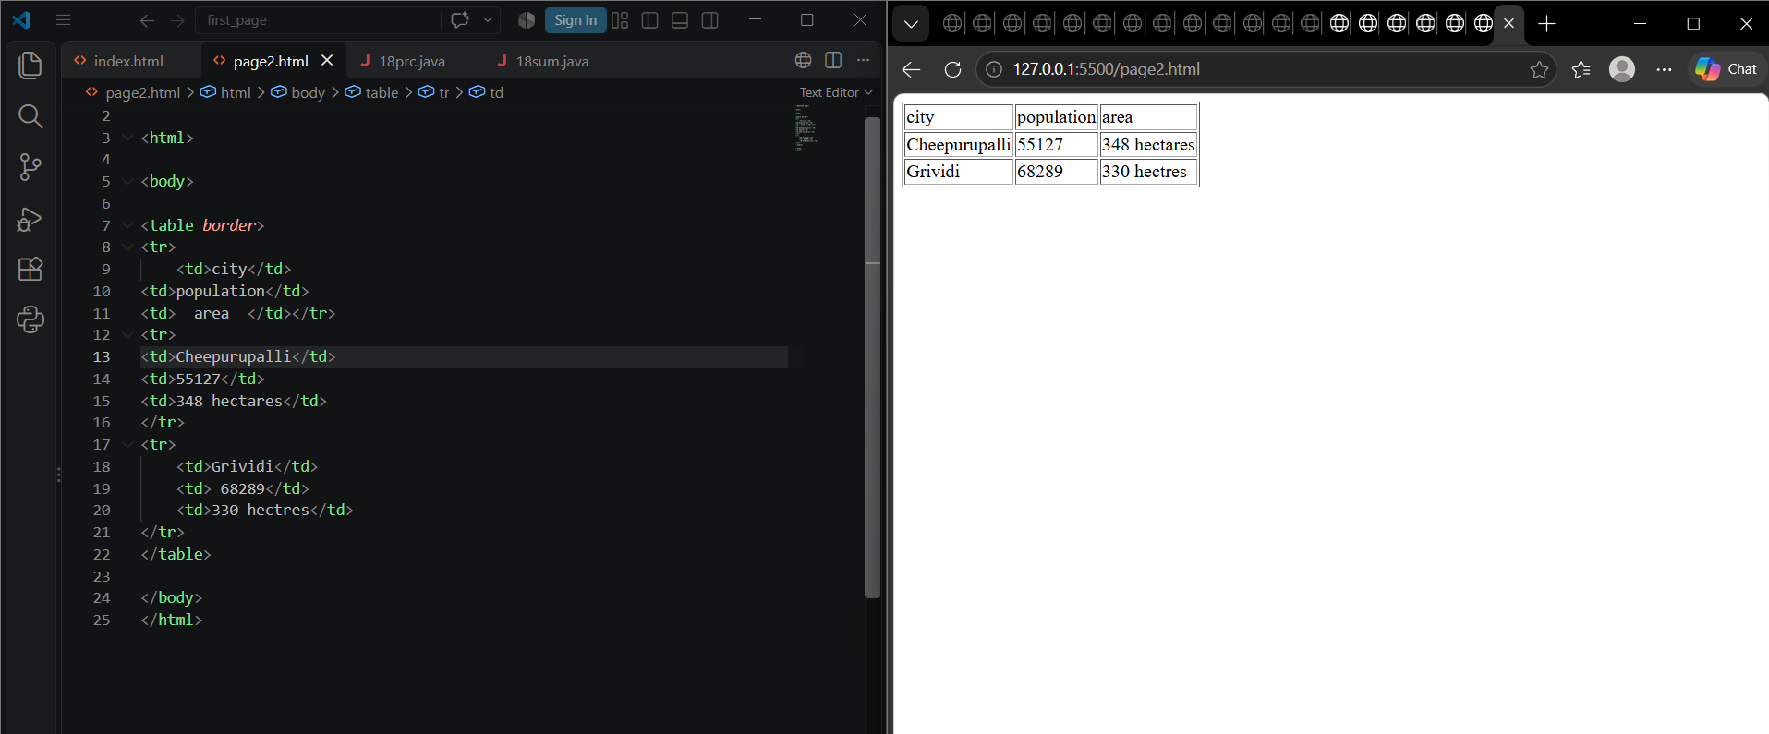
12. Create a Student Details table with:
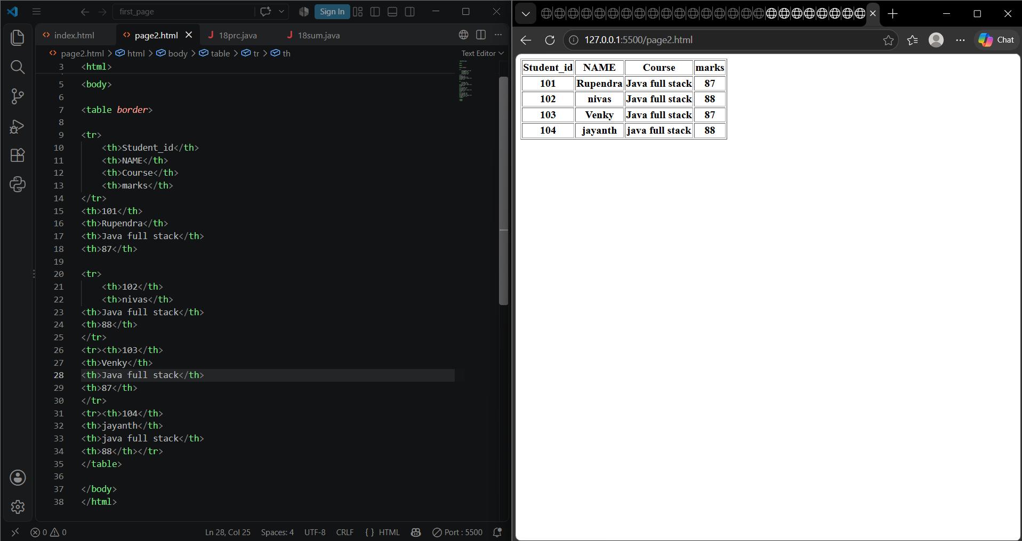
13. Create a table using <th> for headings.

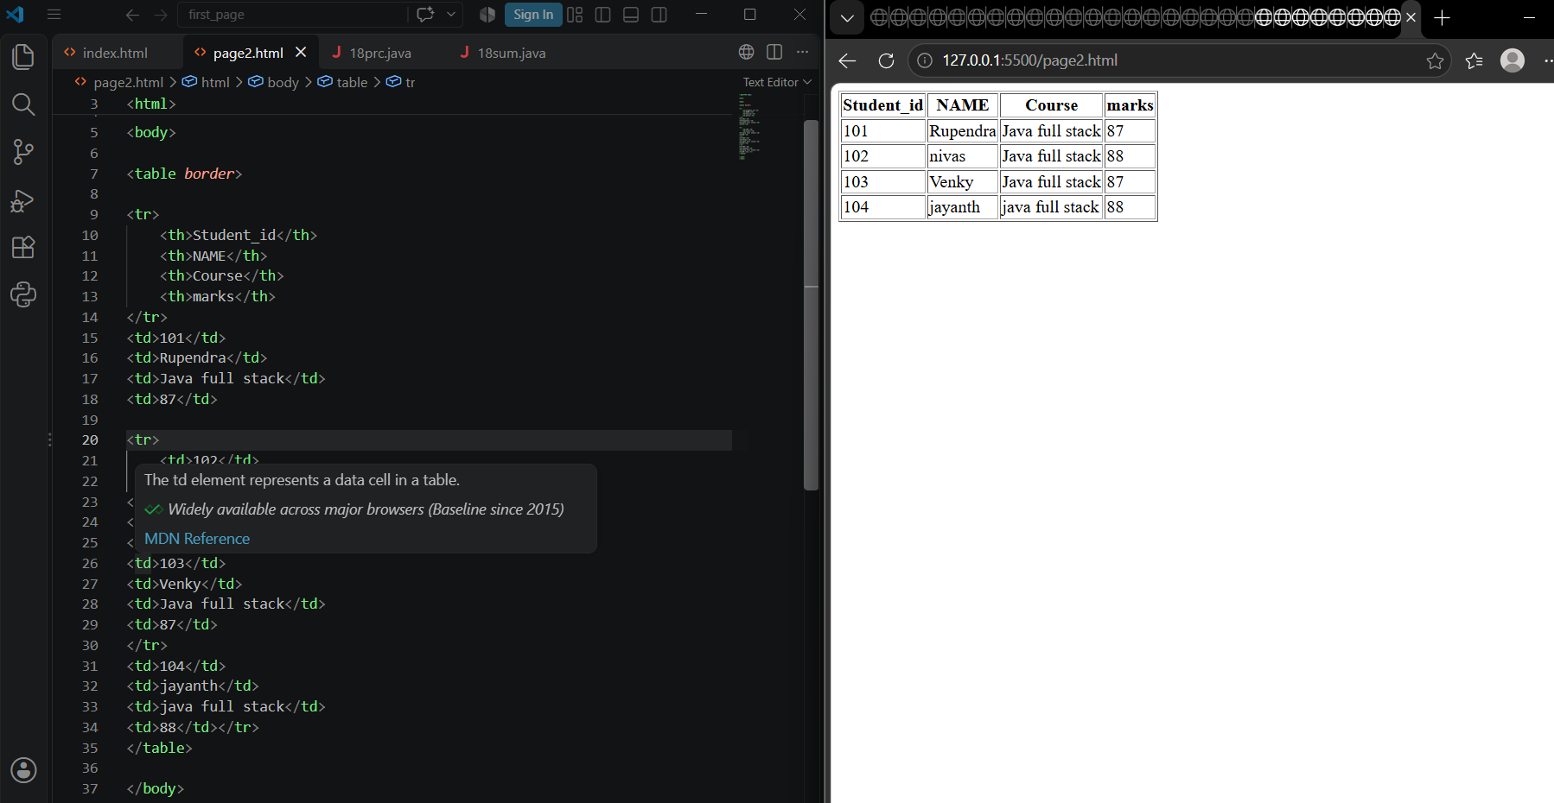
14.Create a table using rowspan.
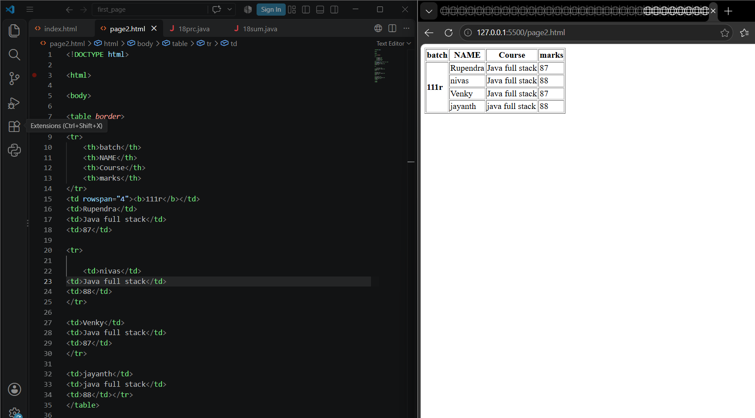
15. Create a table using colspan.
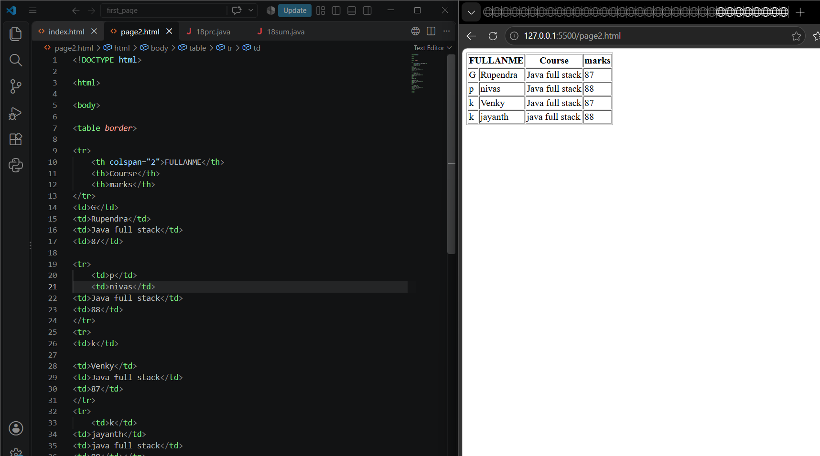
16. Create a 5 × 5 timetable using HTML tables.
